

**Date:** DECEMBER 2, 2018

BONUS ASSIGNMENT REPORT

Class ID: 100337

Subject: Operating System

Group Members:

1. Sameer Rehman (61635)
2. Wasiq Ahmed (61633)
3. Muhammad Sami (8008)

Submitted To:

Sir Ayaz Khan

Table of Contents

**1.1 INTRODUCTION** **1**

**1.2 SCREEN SHOTS AND EXPLAINATION** **1-2**

**1. MODIFICATION** **2**

**1.1 INTRODUCTION:**

In this assignment we make a single link list using by multi-threading. List can contain three functions. First add data and then we get the sum of that list as well as product of the whole list as well as mean

**1.2 SCREEN SHOTS AND EXPLAINATION:**

1. Fist the program take the list size then number add into the list and print it.

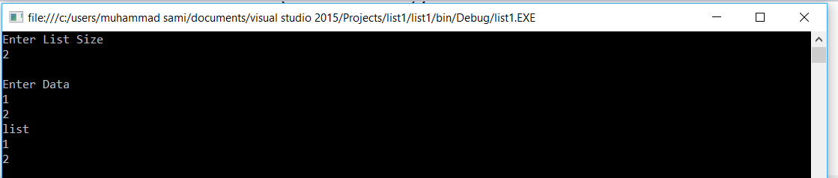

1. Then The program give sum of the all number present in the list.

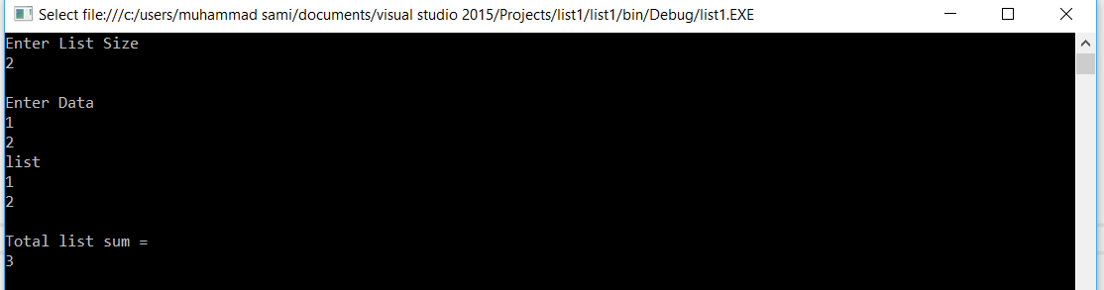

1. The program give the product of the numbers present in the list

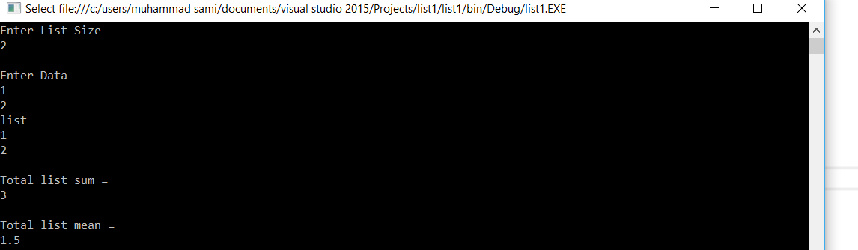

1. Then the program show the mean of the numbers present in list

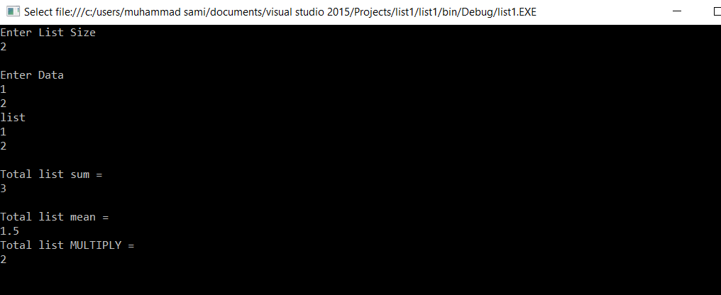

**1.3 MODIFICATION**

You can modify the code r add attribute like delete, divide mode by making a method in the classs and call in into the main for use

EXAMPLE

public void sum()

{

Node node = head;

while (node != null)

{

//Console.WriteLine(node.Data);

v = (v + node.Data);

node = node.next;

}